ATLAS – AFMI IAE de Poitiers
Association Francophone de Management International Delphine Bazerque 05 49 45 44 96
http://www.atlas-afmi.com atlasafmi2020@poitiers.iae-france.fr

10TH INTERNATIONAL CONFERENCE ATLAS-AFMI

18 – 20th MAY 2020

REGISTRATION FORM
Ms Mr First name : Last name :
PhD student Lecturer/Professor Non academic participant
Institution/ Organization :
Business address:
Post code : City : Country :
Phone :
E-Mail :
Billing address (if different) :

Post code : City : Country :

Registration conference fees⁽¹⁾
 | Before 23rd March 2020 | After 23rg March 2020
Lecturer/Professor ⁽¹⁾ | 350 € | 400 €
PhD student ⁽¹⁾ ⁽²⁾ | 250 € | 300 €
Non academic participant ⁽¹⁾ | 350 € | 400 €
Guest (meals only) | 100 € | 200 €
Will you attend ?  Tuesday lunch (19th May)  Tuesday gala dinner (19th May)  Wednesday lunch (20th May) | yes no  yes no  yes no
Do you have a specific diet ? | vegetarian gluten free lactose free vegan
- The conference fees include Atlas AFMI membership, the proceedings of the conference, coffee breaks, two lunches and the gala dinner. Accommodation and transportation are not included.
- Important : Please attach a copy of your student ID card. This fee also applies to retired.

Date : Signature :
Payment (to be attached to the registration form) :
bank check (to Atlas-AFMI) bank transfer university payment order
For payment by wire transfer, pkease indicate the invoice number (given by Ms Sauvetre) on the transfer order

Form to be sent with the payment NOT LATER THAN 15th APRIL 2020
by mail to : atlasafmi2020@poitiers.iae-france.fr
IAE de Poitiers 20 rue Guillaume le Troubadour 86000 Poitiers (France)

Atlas AFMI - Association Francophone de Management International

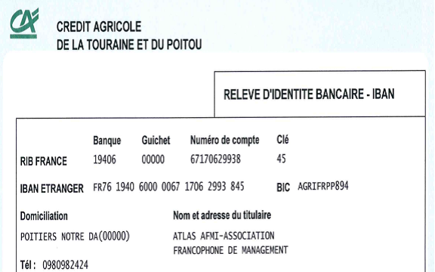

For any request of invoice, please contact :
atlasafmi2020@poitiers.iae-france.fr

For any question about the wire transfer in France, please contact the treasurer of ATLAS-AFMI : sophie.nivoix@univ-poitiers.fr

